Legal Information
https://www.lombardodier.com/legal-information

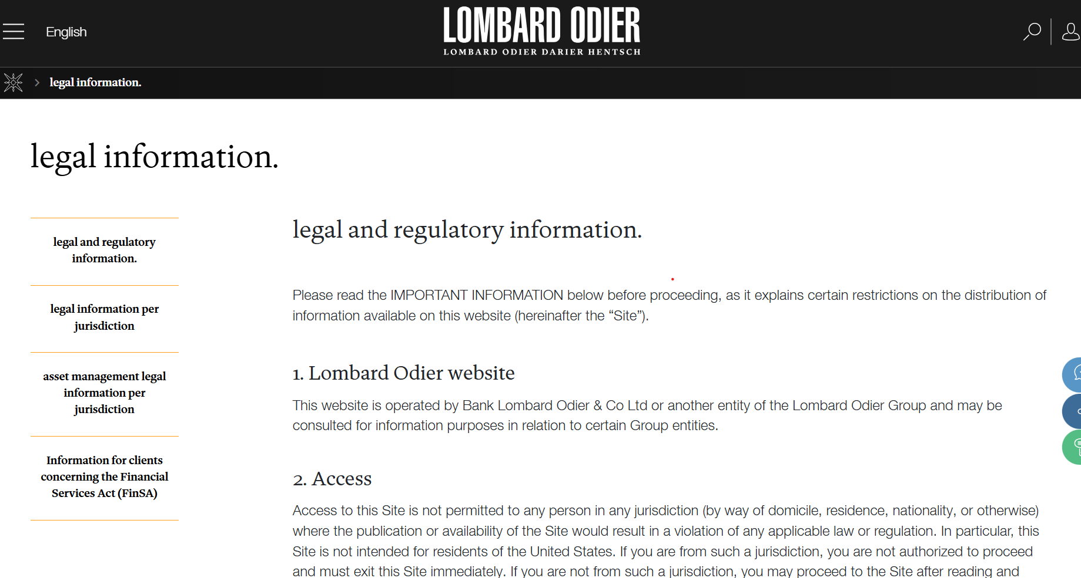

Website Disclaimer
Effective Date: [Date]
This Website is owned and operated by Vidhitra Corporate Advisors LLP ("Vidhitra", "we", "our", or "us"). By accessing or using this Website, you acknowledge and agree to the following:
1. General Information Only
The information published on this Website, including articles, publications, insights, updates, and other materials, is provided solely for general informational purposes. It is intended to offer an overview of legal and commercial developments and should not be regarded as legal, regulatory, financial, or professional advice.
As laws and regulations evolve, the information on this Website may not always reflect the most recent legal developments.
2. No Legal Advice
Nothing on this Website constitutes legal advice or a legal opinion, nor should it be relied upon as a substitute for advice tailored to your specific circumstances.
You should seek independent legal advice before making any decision or taking any action based on information available on this Website.
3. No Advocate–Client Relationship
Your access to or use of this Website, including submitting enquiries, downloading publications, subscribing to updates, or communicating with us through the Website, does not create an advocate-client relationship.
Such a relationship arises only after we have agreed to act for you through a written engagement and completed any necessary conflict checks and regulatory requirements.
4. Professional Standards
Vidhitra Corporate Advisors LLP is committed to upholding the professional and ethical standards applicable to advocates practising in India.
This Website is intended solely to provide information about the firm, its practice areas, and its professional capabilities. It is not intended to solicit clients or advertise legal services in any manner inconsistent with applicable professional rules.
Visitors access this Website voluntarily and on their own initiative.
5. Confidential Information
Please do not submit confidential, privileged, proprietary, or commercially sensitive information through this Website or by email unless expressly requested by one of our lawyers or until a formal engagement has been established.
Information provided to us before an advocate-client relationship has been established may not be treated as confidential and does not create any obligation on the part of Vidhitra Corporate Advisors LLP.
6. Accuracy of Information
We endeavour to ensure that the information published on this Website is accurate and current at the time of publication. However, we make no representation or warranty that the content is complete, accurate, current, or suitable for any particular purpose.
We reserve the right to update, modify, or remove content at any time without prior notice.
7. Past Matters and Publications
Any descriptions of representative matters, transactions, publications, or experience are provided for illustrative purposes only. They should not be interpreted as a guarantee, prediction, or indication of future outcomes or results.
Every legal matter depends on its own facts, applicable law, and circumstances.
8. Third-Party Websites
This Website may include links to third-party websites for your convenience. Such links do not imply endorsement or approval by Vidhitra Corporate Advisors LLP.
We are not responsible for the content, security, availability, or privacy practices of external websites.
9. Intellectual Property
Unless otherwise stated, all content on this Website, including text, publications, graphics, logos, branding, and design elements, is the property of or licensed to Vidhitra Corporate Advisors LLP and is protected by applicable intellectual property laws.
No content may be reproduced, modified, distributed, or commercially used without our prior written permission, except as permitted by applicable law.
10. Contact
If you have any questions regarding this Website or this Disclaimer, please contact:
Vidhitra Corporate Advisors LLP
Email: info@vidhitra.com

Website Terms of Use
Effective Date: [Date]
Welcome to the website ("Website") of Vidhitra Corporate Advisors LLP. These Terms of Use govern your access to and use of this Website. By accessing or using the Website, you agree to be bound by these Terms. If you do not agree, please discontinue use of the Website.
These Terms apply only to your use of the Website and do not govern the provision of legal services, which are subject to a separate written engagement.
1. Use of the Website
You may access and use this Website for lawful personal, professional or business purposes only.
You agree not to:
- use the Website in violation of any applicable law or regulation;
- interfere with the security, operation or integrity of the Website;
- attempt to gain unauthorised access to any part of the Website, our systems or data;
- introduce malware, viruses or other harmful code;
- use automated tools, bots or scraping technologies to access or extract Website content without our prior written consent;
- reproduce, distribute or exploit Website content except as permitted under these Terms of Use; or
- misuse the Website or any contact information published on it.
We reserve the right to restrict, suspend or terminate access to the Website where we reasonably believe these Terms have been breached or where necessary to protect the security or integrity of the Website.

2. Intellectual Property
Unless otherwise stated, all content on this Website, including text, publications, graphics, logos, trademarks, design elements, images, icons, software, audiovisual content, and other materials, is owned by, licensed to, or otherwise lawfully used by Vidhitra Corporate Advisors LLP and is protected by applicable intellectual property laws. Certain content may be owned by third parties and remains subject to the intellectual property rights of its respective owners.
You may view, download, or print content solely for your personal reference, educational, or internal business use, provided all copyright and proprietary notices remain intact. Except as expressly permitted or with our prior written consent, you may not reproduce, modify, distribute, publish, transmit, commercially exploit, or create derivative works from any content on this Website.
Nothing in these Terms grants or transfers any right, title, or interest in the intellectual property displayed on this Website, except the limited right to access and use the Website in accordance with these Terms.
3. Website Content
We take care that the information published on this Website is accurate and current at the time of publication.
However, laws, regulations and business practices evolve, and we do not guarantee that all content will remain complete, accurate or up to date at all times.
We may update, revise or remove Website content without prior notice.
4. Third-Party Links
This Website may contain links to third-party websites for your convenience.
These links are provided for informational purposes only and do not constitute an endorsement or approval of any third-party organisation, product or service.
We are not responsible for the content, security, privacy practices or availability of third-party websites. Your use of such websites is governed by their respective terms and policies.
5. Privacy
Our collection and processing of personal information are governed by our Privacy Policy and Cookie Policy.
By using this Website, you acknowledge that your information may be collected and processed in accordance with those policies.
6. Website Availability
We strive to keep this Website available and functioning effectively. However, we do not guarantee uninterrupted or error-free access.
We may suspend, restrict, modify or discontinue any part of the Website at any time for maintenance, security, operational or other legitimate business reasons without prior notice.
7. Limitation of Liability
Limitation of Liability
To the fullest extent permitted by applicable law, Vidhitra Corporate Advisors LLP shall not be liable in any manner whatsoever for any direct, indirect, incidental, consequential, special, exemplary, or punitive loss or damage arising out of or in connection with your access to, use of, inability to use, or reliance on this Website or its content, including any loss resulting from technical interruptions, errors, inaccuracies, omissions, delays, malware, unauthorised access, or other events beyond our reasonable control.
Nothing in these Terms excludes or limits any liability that cannot be excluded or limited under applicable law.
8. Changes to these Terms
We may update these Terms of Use from time to time to reflect changes in law, technology or our business operations.
The revised version will become effective when published on this Website. Your continued use of the Website after any changes are published constitutes acceptance of the updated Terms.
9. Governing Law
These Terms of Use are governed by the laws of India.
Any dispute arising out of or relating to these Terms or your use of this Website shall be subject to the exclusive jurisdiction of the competent courts at Mumbai, India.
10. Contact
If you have any questions regarding these Terms of Use, please contact:
Vidhitra Corporate Advisors LLP
Email: info@vidhitra.com

Privacy Policy
Effective Date: [Date]
1. Introduction
At Vidhitra Corporate Advisors LLP ("Vidhitra", "we", "our", or "us"), we are committed to protecting the privacy of every individual who interacts with our website and services.
This Privacy Policy has been prepared in accordance with the applicable laws of India, including the Digital Personal Data Protection Act, 2023 ("DPDPA"), and reflects our commitment to responsible, transparent, and secure data practices. This Privacy Policy explains how we collect, use, disclose, store, and protect personal data through our website and related digital platforms.
By accessing or using this website, or by providing your personal data to us, you acknowledge that you have read and understood this Privacy Policy.

2. Scope
This Privacy Policy applies to personal data collected through:
- our website;
- enquiry and contact forms;
- subscription to legal updates or publications;
- recruitment applications;
- event registrations;
- communications with our lawyers and personnel;
- business development interactions; and
- any other lawful interaction with Vidhitra Corporate Advisors LLP through digital channels.
This Privacy Policy does not apply to third-party websites that may be linked from our website.
3. Personal Data We Collect
Depending on your interaction with us, we may collect the following categories of personal data:
Identity Information
- Name
- Professional designation
- Organisation
- Business affiliation
Contact Information
- Email address
- Telephone number
- Business address
Professional Information
- Industry
- Company information
- Nature of enquiry
- Legal or commercial interests relevant to your request
Technical Information
When you visit our website, we may automatically collect information such as:
- IP address
- Browser type
- Device information
- Operating system
- Pages visited
- Date and time of access
- Referring website
- Usage analytics
- Cookie identifiers
Recruitment Information
Where you apply for employment or internships, we may collect:
- Resume or curriculum vitae
- Educational qualifications
- Employment history
- Professional references
- Cover letters
- Other information voluntarily submitted by you.
4. How We Collect Personal Data
We collect personal data:
- directly from you when you complete forms or communicate with us;
- when you subscribe to newsletters or legal updates;
- when you submit employment applications;
- through cookies and similar technologies;
- through business interactions;
- from publicly available professional sources were permitted by law.
5. Purpose of Processing
We process personal data only for legitimate business purposes, including to:
- respond to enquiries;
- communicate with prospective and existing clients;
- assess potential engagements;
- provide requested legal information;
- administer events and seminars;
- publish newsletters and legal insights where subscribed;
- recruit employees and interns;
- improve website functionality;
- analyse website usage;
- maintain security of our systems;
- comply with legal and regulatory obligations;
- establish, exercise or defend legal rights.
We will process personal data only for purposes that are lawful and reasonably necessary.
6. Consent
Where required under applicable law, we process personal data with your consent.
You may withdraw your consent at any time by contacting us using the details provided in this Privacy Policy.
Withdrawal of consent shall not affect processing carried out prior to such withdrawal or processing otherwise permitted under applicable law.
7. Cookies and Similar Technologies
Our website uses cookies and similar technologies to:
- ensure website functionality;
- remember user preferences;
- improve website performance;
- understand visitor behaviour;
- generate website analytics.
You may manage cookie preferences through your browser settings. Further information is available in our Cookie Policy.
8. Disclosure of Personal Data
We do not sell personal data.
We may disclose personal data where necessary to:
- technology and cloud service providers;
- website hosting providers;
- email service providers;
- analytics providers;
- recruitment service providers;
- professional advisers;
- auditors;
- regulatory authorities;
- law enforcement agencies;
- courts and tribunals;
- service providers assisting us in operating our business.
All disclosures are made only where necessary and subject to appropriate contractual or legal safeguards.
9. International Processing
Our technology infrastructure or service providers may process personal data outside India were permitted under applicable law.
Where cross-border processing occurs, the service providers take reasonable measures to ensure that personal data continues to receive an appropriate level of protection consistent with applicable legal requirements.
10. Data Security
Protecting confidential information is fundamental to our professional obligations.
We implement reasonable technical, organisational and administrative measures designed to protect personal data against:
- unauthorised access;
- accidental disclosure;
- alteration;
- destruction;
- misuse;
- unlawful processing.
These measures may include encryption, secure infrastructure, access controls, monitoring, authentication mechanisms and periodic security reviews.
While we strive to protect all information, no method of electronic transmission or storage is entirely risk free.
11. Data Retention
We retain personal data only for as long as reasonably necessary for the purposes described in this Privacy Policy, including to:
- provide requested services;
- comply with legal obligations;
- maintain business records;
- resolve disputes;
- enforce legal rights.
When personal data is no longer required, it will be securely deleted, anonymised or otherwise disposed of in accordance with our internal retention practices.
12. Your Rights
Subject to applicable law, you may have the right to:
- request access to your personal data;
- request correction or updating of inaccurate information;
- request erasure of personal data where applicable;
- withdraw consent where processing is based on consent;
- seek redress of grievances;
- nominate another individual to exercise your rights were permitted under applicable law.
Requests may be submitted using the contact details provided below. We may request reasonable information to verify your identity before responding.
13. Children's Privacy
Our website is intended for business users and adults. We do not knowingly collect personal data from children.
14. Third-Party Websites
Our website may contain links to third-party websites for your convenience.
We are not responsible for the privacy practices, content or security of external websites, and encourage users to review the privacy policies applicable to those websites.

15. Confidentiality of Communications
Submission of information through this website does not by itself create an advocate-client relationship.
Please do not submit confidential, privileged or commercially sensitive information through website enquiry forms unless specifically requested by one of our lawyers.

16. Changes to this Privacy Policy
We may update this Privacy Policy from time to time to reflect changes in law, technology or our business practices.
The updated version will be published on this page together with the revised Effective Date.
Continued use of the website following publication of changes constitutes acceptance of the revised Privacy Policy.

17. Contact and Grievance Officer
For questions regarding this Privacy Policy, requests relating to your personal data, withdrawal of consent, or grievances concerning the processing of personal data, please contact:
Grievance Officer
Vidhitra Corporate Advisors LLP
Email: info@vidhitra.com
We will endeavour to respond within the timelines prescribed under applicable law.
18. Governing Law
This Privacy Policy shall be governed by the laws of India.
Any disputes relating to this Privacy Policy shall be subject to the exclusive jurisdiction of the competent courts at Mumbai, India.

Cookie Policy
Effective Date: [Date]
This Cookie Policy explains how Vidhitra Corporate Advisors LLP ("Vidhitra", "we", "our", or "us") uses cookies and similar technologies on this Website.
What Are Cookies?
Cookies are small text files placed on your device when you visit a website. They help websites function efficiently, remember your preferences, enhance your browsing experience, and provide insights into how the website is used.
How We Use Cookies
We use cookies and similar technologies to:
- ensure the Website functions securely and effectively;
- remember your preferences and settings;
- understand how visitors use the Website to improve its performance and usability; and
- maintain the security and integrity of our digital services.
We do not use cookies to collect information beyond what is reasonably necessary for these purposes.
Types of Cookies We Use
Depending on the functionality of the Website, we may use:
- Essential Cookies – Required for the operation, security, and core functionality of the Website.
- Performance and Analytics Cookies – Help us understand how visitors interact with the Website so that we can improve its performance and user experience.
- Functional Cookies – Remember your preferences to enhance future visits.
Where applicable, we will obtain your consent before using cookies that are not strictly necessary for the operation of the Website.
Third-Party Cookies
Certain features of this Website may rely on trusted third-party service providers, such as analytics or embedded content. These providers may place cookies in accordance with their own privacy and cookie practices.
Managing Cookies
Most web browsers allow you to manage, block, or delete cookies through their settings. Please note that disabling certain cookies may affect the functionality or performance of the Website.
Where available, you may also manage your cookie preferences through our cookie consent banner.
Changes to this Policy
We may update this Cookie Policy from time to time to reflect changes in technology, legal requirements, or the operation of this Website. The revised version will be published on this page together with the updated Effective Date.
Contact
If you have any questions regarding this Cookie Policy, please contact:
Vidhitra Corporate Advisors LLP
Email: info@vidhitra.com

